Complete Offroad
ARBBMB-TJ-YJ
TJ / YJ booster mount compressor bracket for CKSA12 and CKMA12
(TJ 6 cylinder only!)
Air Compressor Bracket Install Instructions
During the installation of this compressor bracket the installer can install the compressor to the bracket before or after the bracket is installed on the JEEP.
Step 1
Remove nuts holding the Brake Proportioning Valve to the Brake Master Cylinder
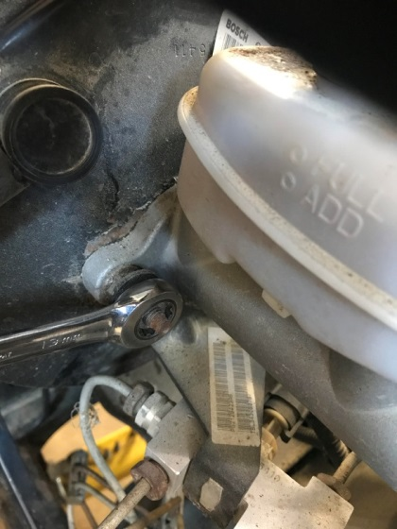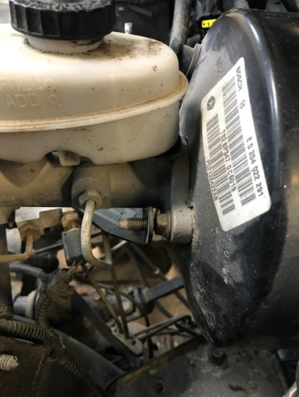
Step 2
Gently move the Brake Proportioning Valve towards the front of the Jeep to allow room to put the Compressor Bracket in place. A prying devise may be helpful in this step but is not required.
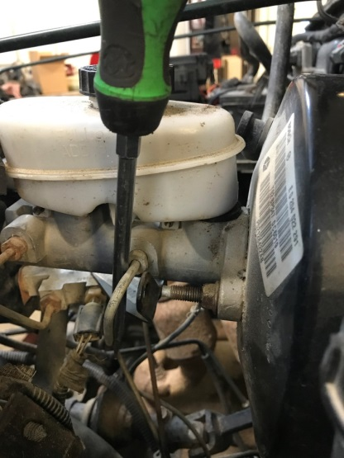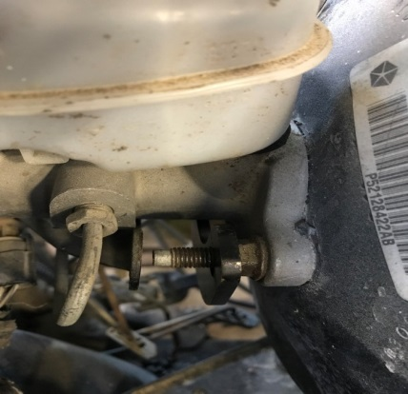

Step 3
With the Compressor Bracket in place, reinstall the Brake Proportioning Valve and original nuts. Tighten nuts to FACTORY Specification.
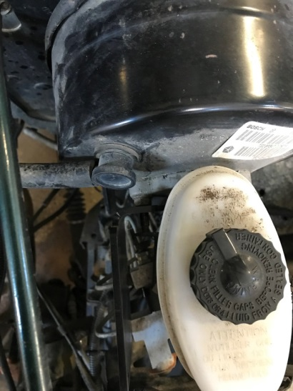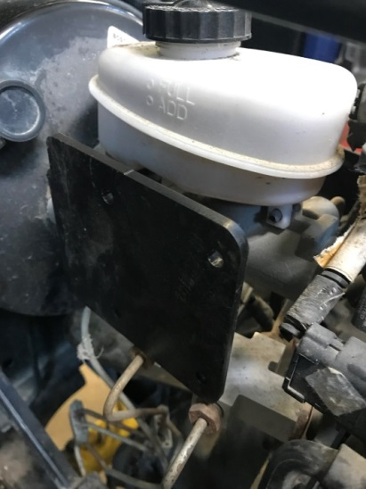

We hope you enjoy your Complete Offroad/Seven Springs Customs Compressor Bracket.
Contact us with any questions or Tech Assistance needs at:
Complete Offroad
2500 Kerper Blvd
Dubuque IA 52001
563-583-5363

